**Thruster Report**

|  |  |
| --- | --- |
| **Thruster Ratio:** | **1.200** |
| **Magnetic Field:** | **125 mT** |
| **Anode Power:** | **881 W** |
| **Anode Current:** | **6.0 A** |
| **Anode Energy:** | **38711.5 J** |
| **Propellant:** | **Argon 0.500 mg/s** |

**Thruster Details: Nagoya magnet, LaB6 cathode, 1 mm orifice, copper anode, 80 mm internal diameter. CoM correction method: Anode Energy, Pre-offset 0.0 s, Post-offset 100.0 s, Cold-Gas thrust 0.1 mN**

|  |  |  |  |  |  |  |
| --- | --- | --- | --- | --- | --- | --- |
| Thrust | Thrust Eff. | ISP | Total DOF | Coverage Factor | Exp. Uncertainty | Std. Uncertainty |
| 7.1 mN | 5.7 % | 1438.8 sec | 12 | 2.11 | 2.7 mN | 1.3 mN |

**Thrust-Stand Uncertainty Components**

|  |  |  |  |  |  |  |  |
| --- | --- | --- | --- | --- | --- | --- | --- |
|  | Weights | Scale | Hysteresis | Repeatability | Noise | Offset | Drift |
| Value | 0.0 mN | 1.0 mN | 0.4 mN | 0.2 mN | 0.4 mN | 0.1 mN | 0.3 mN |
| DOF | 30 | 6 | 6 | 6 | 31 | 4 | 4 |

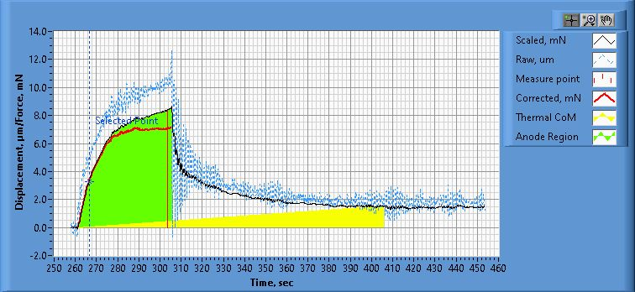

**Figure 1. Thrust Plot**

File Name: Philtech Data 2025.04.17_00.12.53.csv

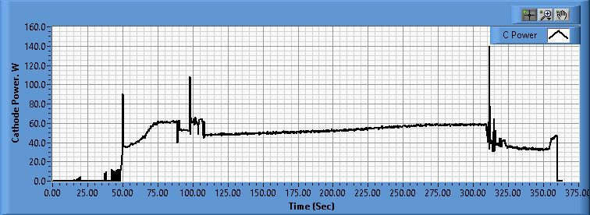

**Figure 2. Cathode Power Plot**

File Name: PSU C Data 2025.04.17_00.12.05.csv

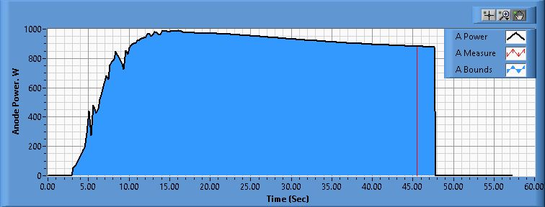

**Figure 3. Anode Power Plot**

File Name: PSU A Data 2025.04.17_00.17.11.csv

**Pre-Cal. Information**

File Name: Philtech Data 2025.04.16_23.55.41.csv

Start/Stop times (24 h): 23:55:49 23:59:35

Sensitivity: 1.47 um/mN

|  |  |  |  |
| --- | --- | --- | --- |
| Offset | Drift | Scale Factor | Scale Std.Dev |
| 0.027 mN | 0.001 mN/s | 0.682 | 1.426 mN |

Plateau values:

|  |  |  |  |  |  |  |  |  |  |  |
| --- | --- | --- | --- | --- | --- | --- | --- | --- | --- | --- |
| Weight 0 | Weight 1 | Weight 2 | Weight 3 | Weight 4 | Weight 5 | Weight 4 | Weight 3 | Weight 2 | Weight 1 | Weight 0 |
| -0.1 mN | 22.2 mN | 38.5 mN | 59.7 mN | 80.2 mN | 101.0 mN | 79.1 mN | 59.1 mN | 38.1 mN | 21.9 mN | 0.0 mN |

**Post-Cal. Information**

File Name: Philtech Data 2025.04.17_00.12.53.csv

Start/Stop times (24 h): 00:21:05 00:24:56

Sensitivity: 1.46 um/mN

|  |  |  |  |
| --- | --- | --- | --- |
| Offset | Drift | Scale Factor | Scale Std.Dev |
| -1.639 mN | -0.009 mN/s | 0.685 | 1.313 mN |

Plateau values:

|  |  |  |  |  |  |  |  |  |  |  |
| --- | --- | --- | --- | --- | --- | --- | --- | --- | --- | --- |
| Weight 0 | Weight 1 | Weight 2 | Weight 3 | Weight 4 | Weight 5 | Weight 4 | Weight 3 | Weight 2 | Weight 1 | Weight 0 |
| -0.0 mN | 21.4 mN | 38.4 mN | 59.3 mN | 79.6 mN | 100.2 mN | 79.4 mN | 59.0 mN | 37.6 mN | 21.5 mN | 0.1 mN |